COST TO ADOPT A FERRET FROM FUZZY FERRET RESCUE



There is not a “set” adoption fee. It depends upon the ferret - its age, its health, how well it gets along with other ferrets here, how many ferrets there are here, etc. Adoption fees range from free ($0) for an older ferret with adrenal disease to $260 for a young healthy one.

All rescue ferrets under 5 years old will receive both of their needed distemper vaccinations & have been treated with Revolution for Fleas, Heart Worms, Ticks & Ear Mites. They are well socialized to both other ferrets & humans. We work with them so they don't bite & constantly work with them on litter box training. We allow them to interact with humans, dogs & other ferrets; therefore, we know their personalities, as well as what they like to eat & play with. So, you don't have to waste money on toys they won't touch.

**The vaccinations are FREE if you adopt/foster from Fuzzy Ferret Rescue!**

Ferrets here at the rescue, are fed **ONLY PREMIUM QUALITY** ferret foods, so they are as healthy as possible, with great appetites & go home already eating something good for them. Some ferrets are very picky & will not eat a certain food purchased; that said, this can be VERY frustrating to a new adopted family, so we want to make sure the adopted/fostered ferret has what they need. Once the ferret is chosen, we will talk about what they eat, or should we say, “what they have picked to eat”, and what they play with. Anytime a ferret has a “favorite toy” we try our best to send it home with that ferret.

**Fuzzy Ferret Rescue has a “store” here with ALL your ferret’s needs & more!**

**WE WILL SEND HOME A 7-DAY SUPPLY OF FOOD WITH EACH FERRET!**

**POTENTIAL VET BILLS**

Vet Visit w/ the FIRST Distemper Vaccination Up to $150.00

Vet Visit w/ the SECOND Distemper Vaccination &

Revolution for 6mo. Up to $210.00

_________________________

Up to $360.00

**THESE POTENTIAL BILLS ARE COVERED ON ANY ADOPTION/FOSTER!**

-VERSES-

**PET STORE FERRETS**



Pet store ferrets are typically sold for $250-$325, with the understanding they have received BOTH distemper vaccinations & treated with Revolution. Sadly, the majority, have **NOT** & now that you have purchased a $250-$325 ferret, you will need to take it to the vet **IMMEDIATELY**! Already racking up those vet bills $

Pet store ferrets are supposed to get both distemper vaccinations BEFORE they are purchased, but often times – this is NOT the case! Since there is no “proof” of those vaccinations, you **MUST** make sure they get BOTH VACCINATIONS- IMMEDIATELY!

Note: This will be 2 separate vet visits. -see below-

Pet store ferrets are also supposed to be treated with Revolution (prescription only) for fleas, heart worms, ticks & ear mites BEFORE they are purchased, but again – this is NOT the case most of the time! Again, since there is no “proof” of that treatment, you **MUST** make sure they get treated- IMMEDIATELY! -see below-

Pet store ferrets are VERY young. Often times, they are taking from nursing too soon & they have a hard time catching up to those ferrets that were taken from nursing at the appropriate time. Often times when this happens, you will get the ferret home & over the next 48-hours you will become VERY concerned & have to take the ferret to vet –

$ MORE IMMEDIATE VET BILLS $

Pet store ferrets are **NOT** socialized to either other ferrets or humans. Most of the time, these ferrets haven’t had ANY human interaction, much less positive interaction. Unlike rescue ferrets, pet stores do NOT work with them so they may bite. That said, 9 out of 10 times, a pet store ferret has never seen a litter box, much less used it. Pet store employees don not have the time (or take the time) to interact with the baby ferrets; therefore, pet stores know NOTHING about the ferrets personalities, food preference, toy preferences or bed/bedding.

**IMMEDIATE - POTENTIAL VET BILLS**

Vet Visit w/ the FIRST Distemper Vaccination Up to $150.00

Vet Visit w/ the SECOND Distemper Vaccination &

Revolution for 6mo. Up to $210.00

_________________________

Up to $360.00

**THESE IMMEDIATE - POTENTIAL VET BILLS ARE YOUR RESPONSIBILITY!**

**IMMEDIATE - POTENTIAL VET BILLS**

-2 vaccination visits & prescription for Revolution-

Vet Visit w/ the FIRST Distemper Vaccination Up to $150.00

Vet Visit w/ the SECOND Distemper Vaccination &

Revolution for 6mo. Up to $210.00

_________________________

Up to $360.00

**THESE IMMEDIATE - POTENTIAL VET BILLS ARE YOUR RESPONSIBILITY!**

**IMMEDIATE - POTENTIAL VET BILLS**

-2 vaccination visits, prescription for Revolution, multiple nutrition visits

(typically 6 visits) because they were pulled from nursing too young-

Vet Visit w/ the FIRST Distemper Vaccination Up to $150.00

Vet Visit w/ the SECOND Distemper Vaccination &

Revolution for 6mo. Up to $210.00

Vet Visit for Nutrition Up to $175.00

Vet Visit for Nutrition Up to $175.00

Vet Visit for Nutrition Up to $175.00

Vet Visit for Nutrition Up to $175.00

Vet Visit for Nutrition Up to $175.00

Vet Visit for Nutrition Up to $175.00

_________________________

Up to $1,410.00

**THESE URGENT & IMMEDIATE - POTENTIAL VET BILLS ARE YOUR RESPONSIBILITY!**

EXPENSE OF HAVING A FERRET



Below are some examples, so you have a better idea of the expense involved.

Ferret food needs to be really high in protein and fat, which means it can get expensive. One of the best foods is Wysong Epigen. It costs $29 for five pounds. Ferrets eat about a pound of food per week, so a 5-pound bag will last roughly 5 weeks, which breaks down to roughly $6.00 a week, FOR **ONE** FERRET! So if you have multiple ferrets OR are planning to adopt multiple ferrets – just remember, food for your ferrets will run you roughly $6.00 for EACH FERRET YOU HAVE! -see below-

There is a high chance your ferret will get Adrenal Disease. Don’t panic, this is VERY common. About 75% of ferrets will get Adrenal Disease. This involves 3 treatments over time, including a Melatonin Implant (lasting 4-5 months), a Deslorelin Implant (lasting 12-14 months) & surgery. -see below-

There is a high possibility your ferret will get Insulinoma. Don’t panic, this is also VERY common. Roughly, 50% of ferrets will get Insulinoma, as they get older. This usually requires several vet visits to get the ferret stabilized, medication twice a day (or more if the ferret needs it) that comes from the vet ONLY (prescription only) & vet visits about twice a year for the Insulinoma. -see below-

Ferrets get Gastrointestinal Blockages, very easily, because they will eat ANYTHING & EVERYTHING off the floor. I had a ferret eat a 1/8" metal spring off the floor – so when I say they will eat ANYTHING & EVERYTHING – they will! It cost me $720 (over five days) to get him taken care of.

Client Stories About Their Ferrets With Blockages:

1. Also, a young lady contacted me, in a panic, because her ferret was dying from a blockage. The ferret had chewed on material & swallowed a ¼” piece of that material. She had already spent $350 at a vet & had received quote from her vet for roughly $3,000 to do surgery. Luckily, her ferret did NOT die, and she called around and found a vet that would do the SAME procedure for $600.
2. I got a call around midnight one night, a kid’s ferret wasn’t acting right. She took the ferret to the emergency vet (which are like human emergency rooms – VERY EXPENSIVE) & then her regular vet the next day to follow up. She spent over $1,000 at the emergency vet & then another $180 at her normal vet.
3. Another friend took her ferret to the vet for its scheduled distemper vaccination. Unfortunately, she ended up spending $650 because the vet felt something in the ferret's abdomen that had to be checked out. Apparently, the ferret had eaten a sticker, swallowed it & it caused a blockage! She had NO IDEA!
4. Fuzzy Ferret Rescue was planning on boarding a ferret from Thursday at 6:00pm to Monday at 6:00pm. The owner arrived at Thursday around 6:00pm & while I was asking her few boarding questions, her ferret laid over & his stomach was extremely distended. She rushed him to the emergency vet (which are like human emergency rooms – VERY EXPENSIVE), they ran a couple tests & found the blockage & he required emergency surgery to remove the blockage. Come to find out, the afternoon before (Wednesday) she found her ferret shredding a plastic ball, she had NO IDEA her ferret had eaten it too! Her bill was around $1,500.
5. A dear friend had a ferret get into her storage closet. Her grandson had not closed the door & the ferret found its way into that closet. Her ferret got into something & spent two days at the vet on IV fluids & critical care - then had follow up care at a cost of nearly $2,000.

With ALL that said, when I say they will eat ANYTHING & EVERYTHING – THEY WILL!!!

Below is a ROUGH financial explanation to owning ONE ferret.

ONE FERRET:

Food $6.00 per week

Melatonin Implant $45.00 plus the vet visit lasting 4-5 months

Deslorelin Implant $160 plus the vet visit lasting 12-14

Blockage Treatment $40.00 at home, using Ferret LAX works

Surgery for Blockage $320.00 & up…

Insulinoma Treatment $5-25.00 plus the vet visit , every 6 months

NEW FERRET - WHAT TO EXPECT

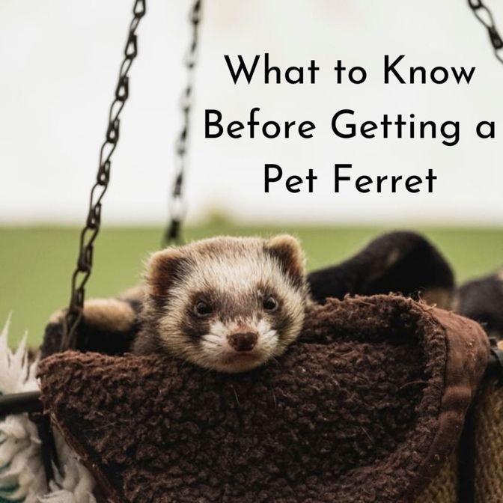

When a new ferret comes into the home, it's going to be very excited & run to check out everything. Once it's finished checking out everything, the ferret will usually find a place to sleep & they will sleep hard! It will usually sleep more than normal for 2-3 days, so don’t panic.

Any change in a ferret’s environment is stressful. A stressed ferret can get sick easily & quickly. The ferret sleeps more than normal to give the body a chance to de-stress & keep from getting sick.

During the first few days, allow the ferret to sleep. Do NOT awaken the ferret to play or to show it off. Let it sleep as much as it wants. Do NOT take the ferret anywhere or do anything different with it (like bathing, changing food, rearranging cage, etc.). Allow the ferret to stay at home where it can be calm, sleep & not be under any more stress. If possible, do not introduce other non-ferret pets to the new ferret for several days, to keep the stress to a minimum.

If you are introducing your new ferret to another ferret that you already had, & the introduction does NOT go well, don’t panic! Simply wait 24-48 hours before trying again, so that it doesn't increase the stress level for the new ferret.

The ferret may also have diarrhea for several days, don’t be alarmed. This is normal & the body’s way of dealing with stress. The diarrhea may even be bright green. Bright green diarrhea should be for a day or two (a maximum of 4 days). The ferret should still be eating & drinking during this time. If the ferret is NOT eating & drinking, then contact a vet’s office or Fuzzy Ferret Rescue. A ferret can get a bacterial infection from stress & may need to be seen by a veterinarian immediately.